ASSIGNMENT-3
ESE – 3005
EMBEDDED SYSTEMS ARCHITECTURE 2

Submitted to :
Linchan Wang
Submitted by:
Gurvinder Singh(748418)

Systemctl Performed on Beaglebone
a.) Create a service file
cp /lib/systemd/system/crond.service /lib/systemd/system/sleep.service

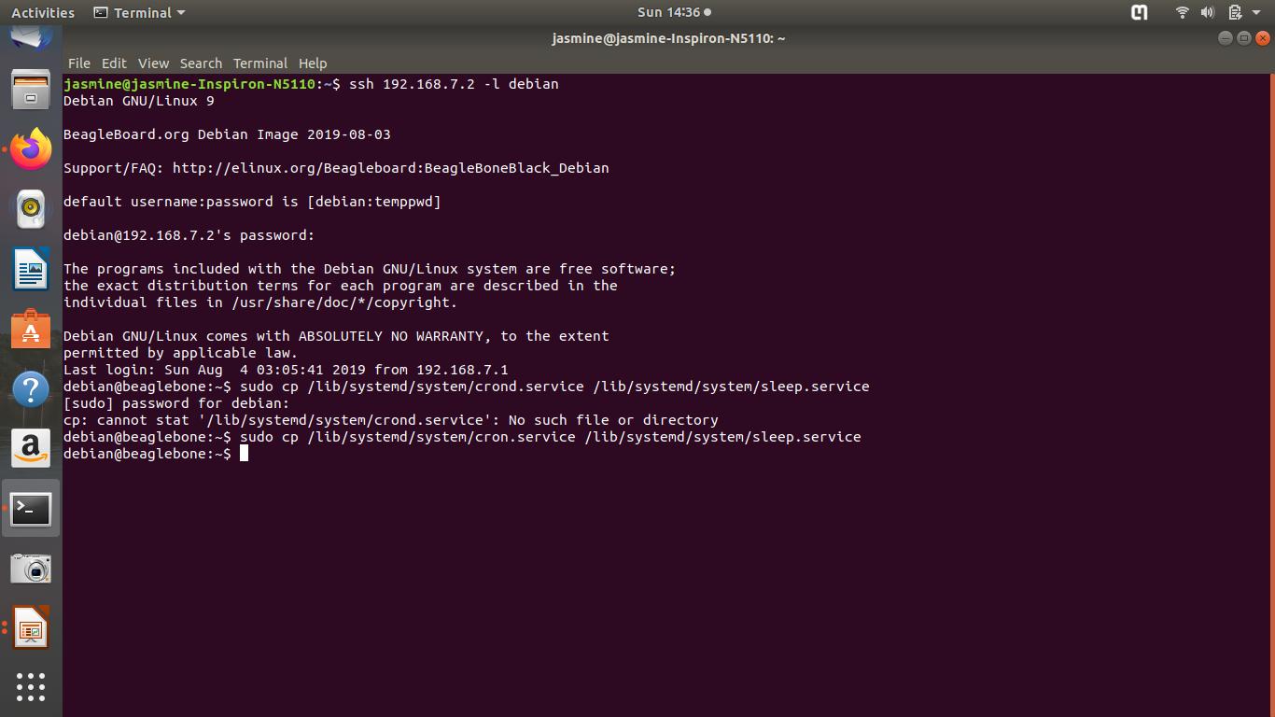

b.) vi /lib/systemd/system/sleep.service

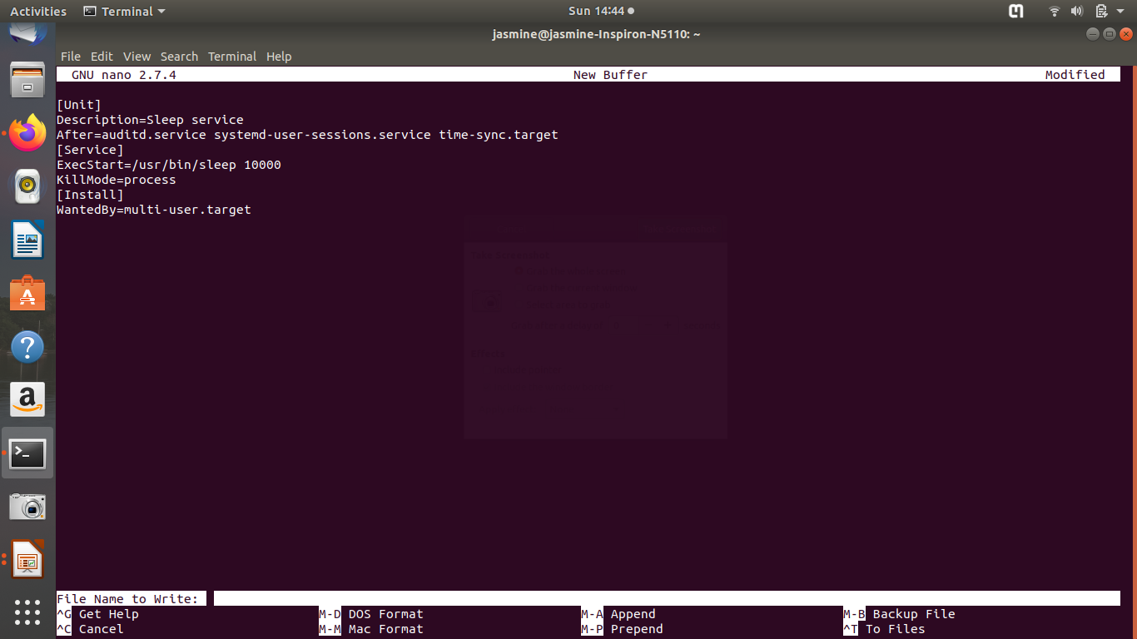

c.) systemctl enable sleep.service
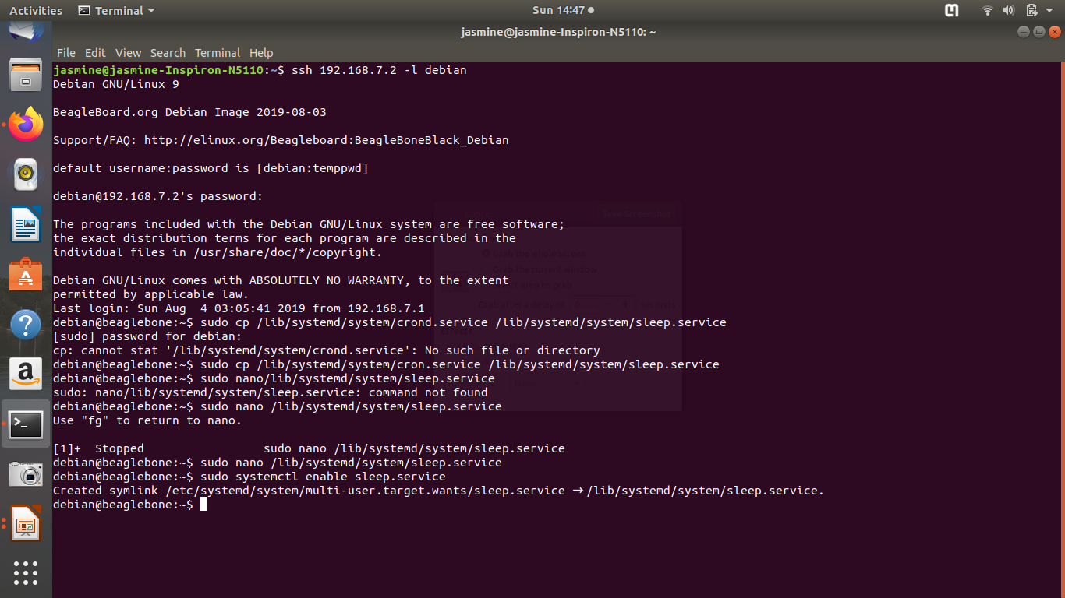

d.) systemctl start sleep.service
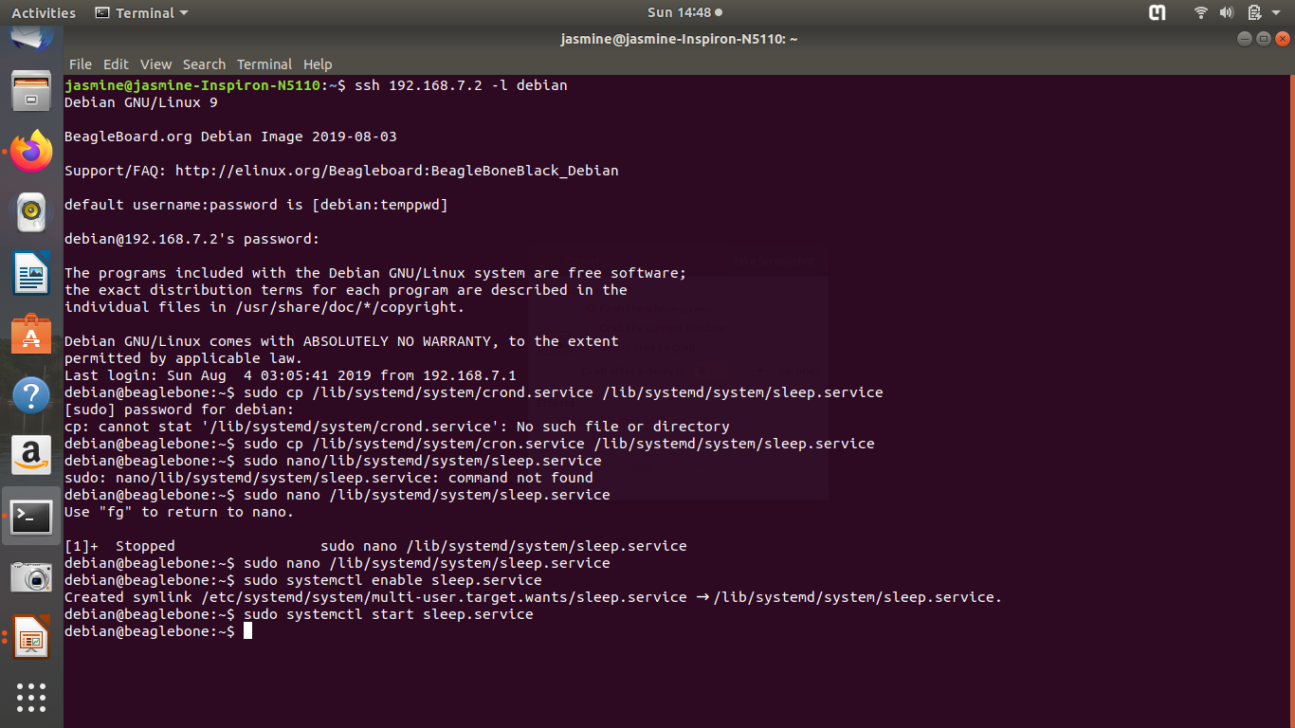

e.) systemctl status sleep.service

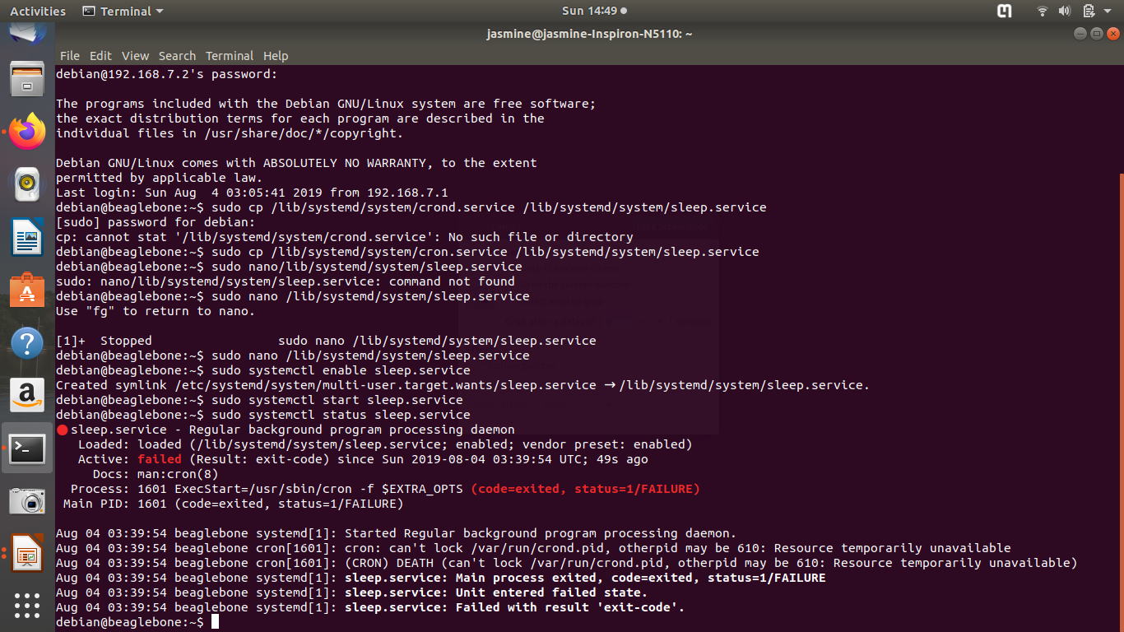

f.) systemctl stop sleep.service

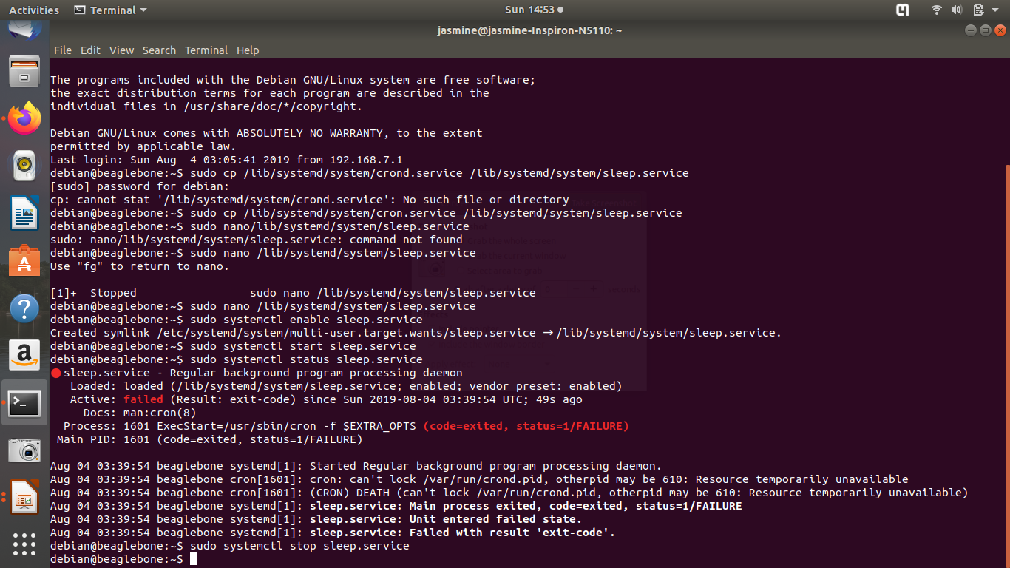

g.) systemctl disable sleep.service

